Copy Resource Guide

The following resource families have new 2026 requirements:
- Vehicle with Driver
- Fuel Tender
- Mechanic with Service Truck
If you want to add previously awarded resources in these families to a new 2026 solicitation, you will have to make copies of the resources in your profile so they can be evaluated against these new requirements. Once you have completed the steps detailed below, your resource should be in a “Complete – Qualified” status and ready to submit in a quote on a new solicitation.
Important Note: Please make all edits in the resource wizard as soon as you copy the resource. Do not exit the wizard (including via “Save As” or “Submit”) until all edits are accurate and complete. You will not be able to make further edits once the wizard is closed.

How To Guide

Step 1
Access your Vendor Profile and enter into the Resources Tab
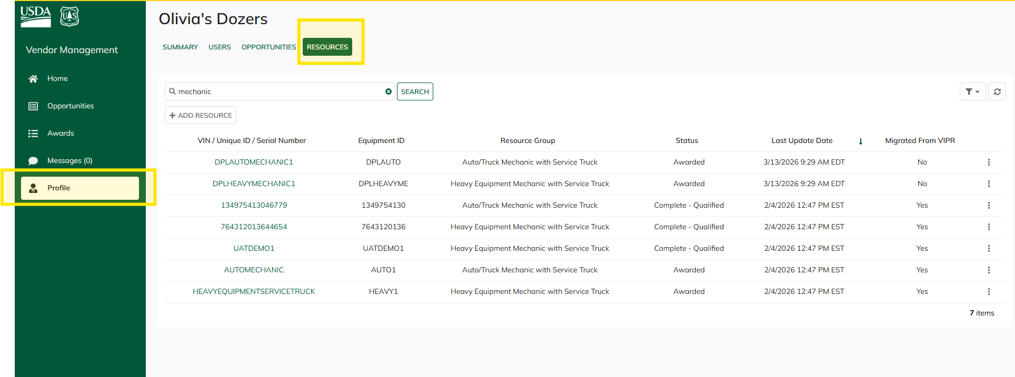

Step 2
Locate the resources that you want to copy, click the three dots on the right and choose “Copy Resource”
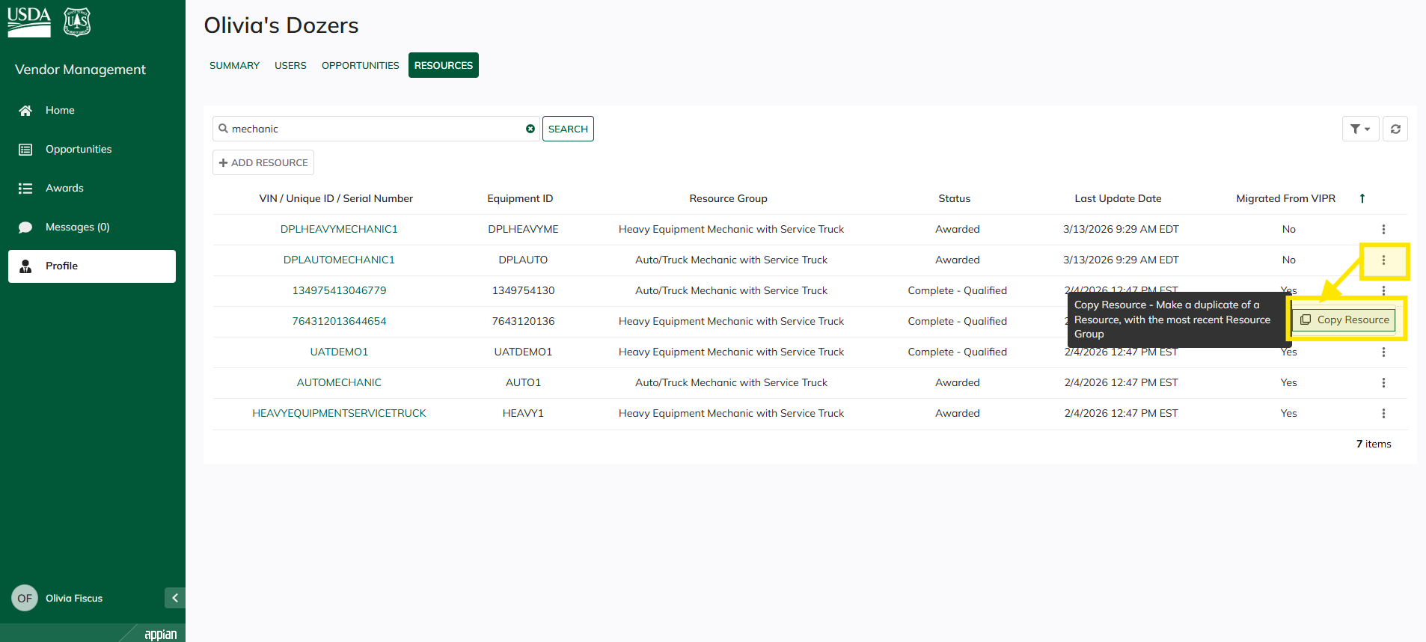

Step 3
Completely fill in all the Tabs on the left side of the Resource Wizard. Note that the tab names will change depending on the resource family you are copying
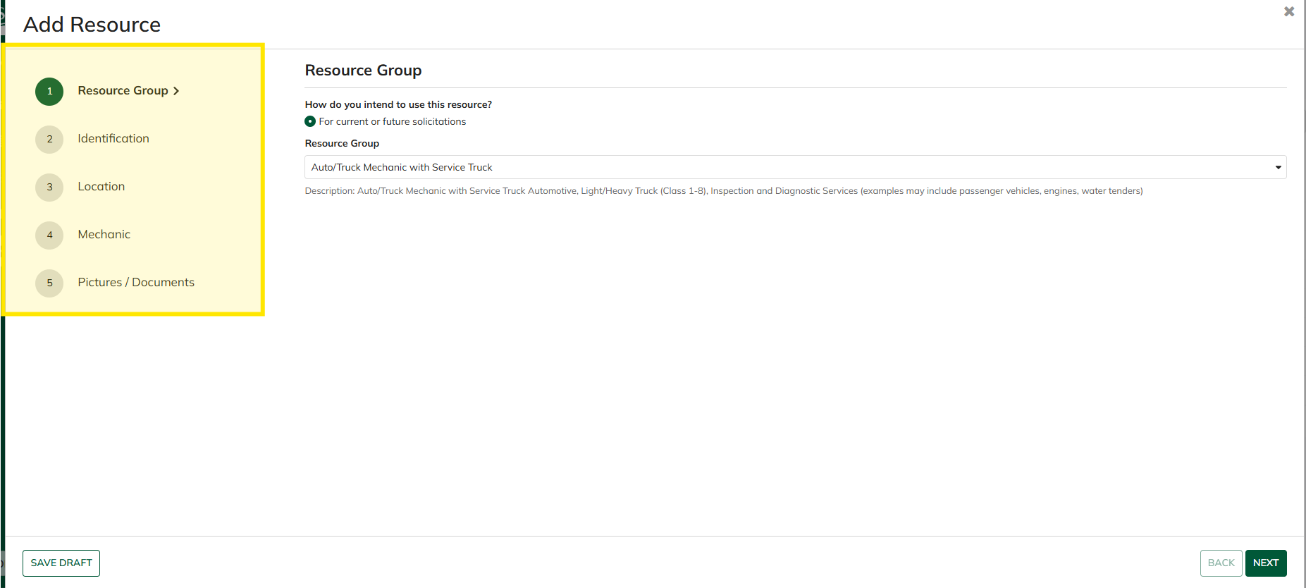

Step 4
Submit the resource wizard once you are confident that all changes are complete and accurate
